Course _______Specialist______ Year __12_____

Student name: ________________ Teacher name: ________________

Date: 24 Feb

Task type: Response

Time allowed for this task: _____45______ mins

Number of questions: _____8______

Materials required: Calculator with CAS capability (to be provided by the student)

Standard items: Pens (blue/black preferred), pencils (including coloured), sharpener, correction fluid/tape, eraser, ruler, highlighters

Special items: Drawing instruments, templates, notes on one unfolded sheet of
A4 paper, and up to three calculators approved for use in the WACE examinations

Marks available: __50____ marks

Task weighting: _10___%

Formula sheet provided: Yes/No

Note: All part questions worth more than 2 marks require working to obtain full marks.

Q1 (3.1.1, 3.1.2, 3.1.3) (2, 2, 3 & 3 = 10 marks)
If and determine exactly the following. (Simplify)
- Solution

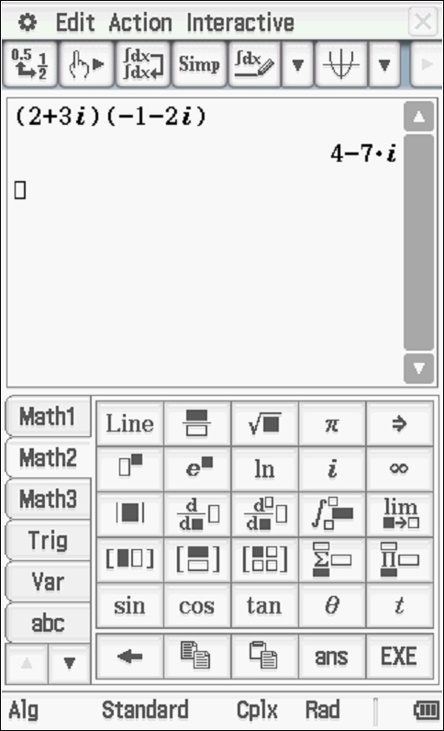

Specific behaviours
determines conjugate of w
determines product

Solution
Specific behaviours
gives a real result
determines product

Solution
Specific behaviours
multiplies by conjugate over conjugate
evaluates numerator
evaluates denominator

Solution
Specific behaviours
uses idea of conjugates
expresses both reciprocals with real denominator
determines correct simplified sum

Q2 (3.1.3) (3 marks)
Determine all possible real values of such that

Solution

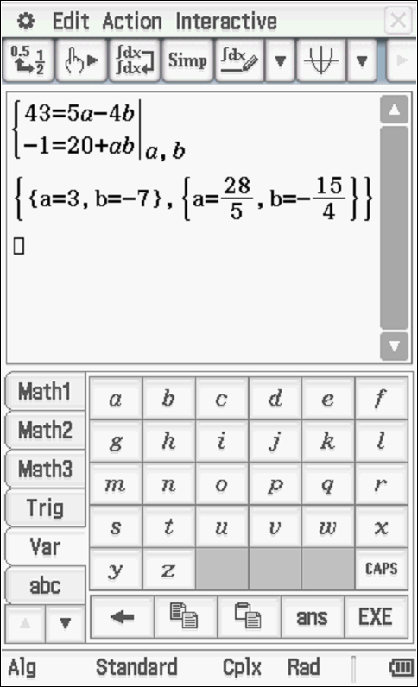

Specific behaviours
sets up one equation involving a or b
sets up two equations for a & b
solves for two pairs of real values for a & b
Q3 (3.1.14, 3.1.15) (3& 3 = 6 marks)
Consider the quadratic equation where are real.
- If one root of the above equation is , determine .

Solution
Specific behaviours
sets up one equation involving c or b
sets up two equations for c & b
solves for one pair of real values for c & b

Consider the equation where are real.

- If the cubic equation above has roots , determine .

Solution
Specific behaviours
recognises that conjugate also a root
expands at least two linear factors
solves for p,q&w

Q4 (3.1.3, 3.1.3, 3.1.3) (2 marks)
Determine in the form with . (Note: diagram not drawn to scale)

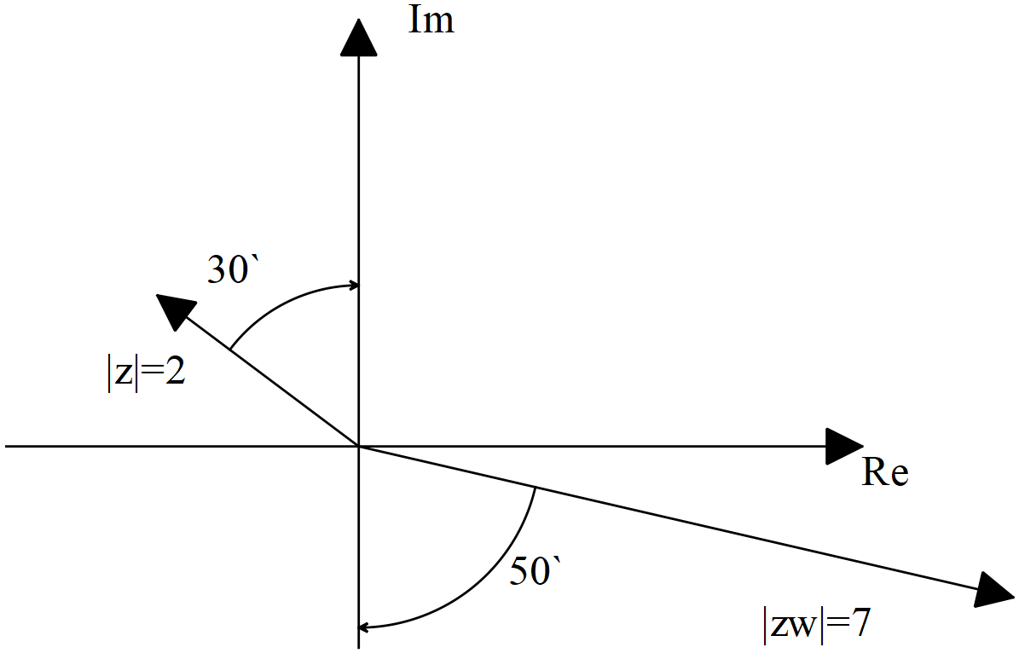

Solution

Accept radians or degrees
Specific behaviours
determines z with principal argument
determines w with principal argument

Q5 (3.1.10) (2, 2 & 3 = 7 marks)
Sketch the following regions in the complex plane showing major features.

Solution

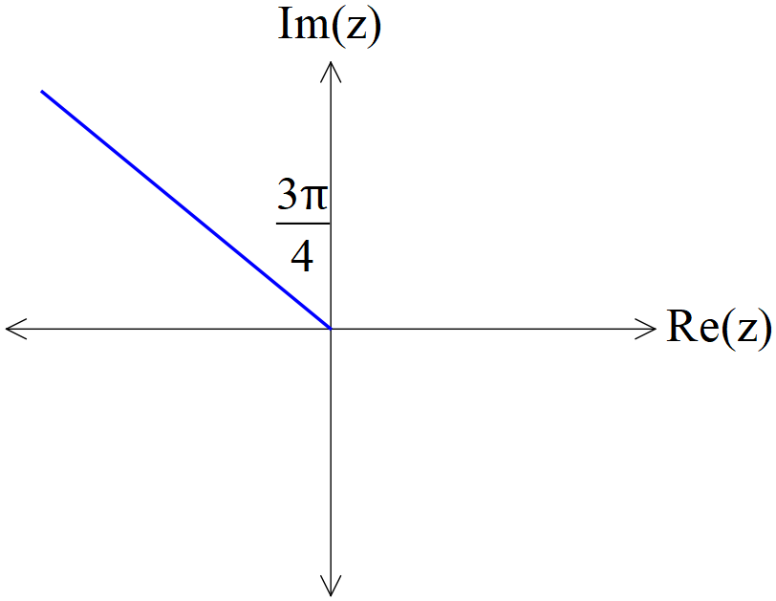

Specific behaviours
uses line y=-x
only drawn for Re(z)<0 (allow zero)

Solution

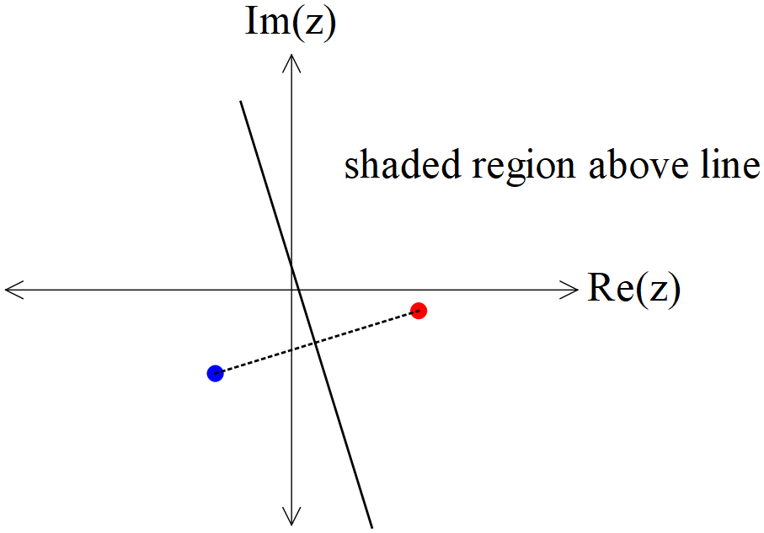

Specific behaviours
plots correct points
shades above perpendicular bisector

- Consider all the complex numbers that satisfy , determine the maximum possible value of , giving your answer in radians correct to two decimal places.

Solution

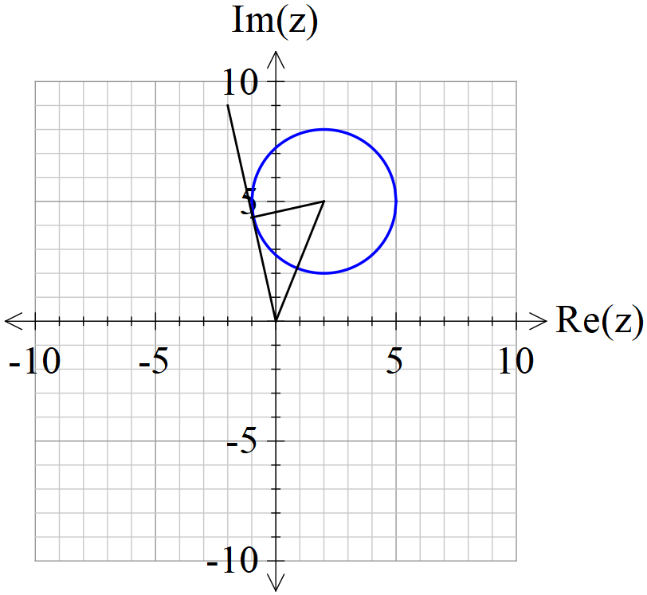

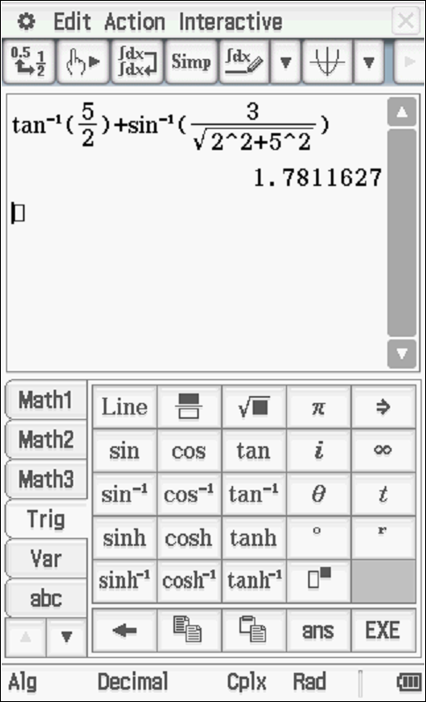

Specific behaviours
determines argument of centre of circle
uses left tangent idea for max argument
solves for max argument in radians(no need to round to 2 dp)

Q6 (3.1.7, 3.1.12) (4 & 3=7 marks)
- Determine all the roots of expressing in the form with .

Solution
Specific behaviours
expresses right hand side into polar form
uses De Moivre’s theorem
obtains five distinct roots in polar form
uses principal arguments for all roots

- Plot all of these roots on the diagram below.

Solution

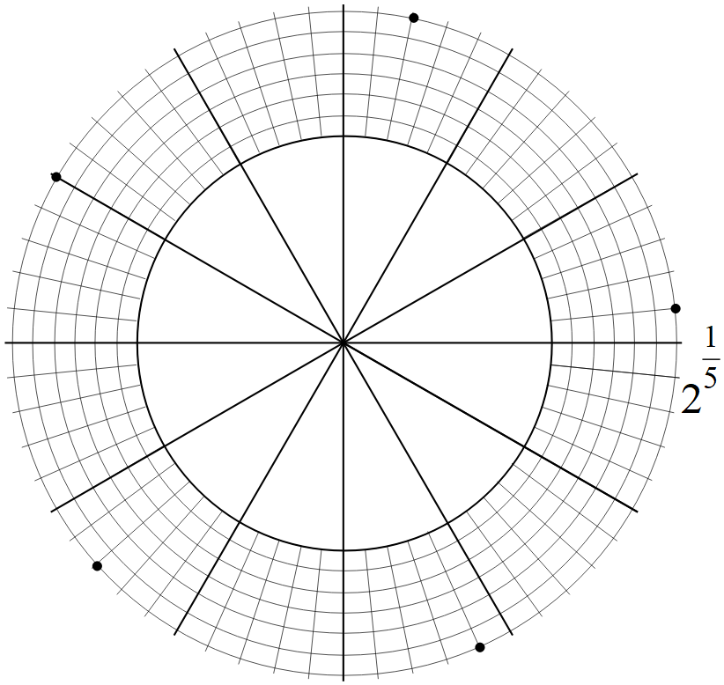
Specific behaviours
shows scale
plots one root correctly
all five roots equally spaced
Q7 (3.2.1, 3.2.2) (1, 2, 2 & 2 = 7 marks)
Consider the functions .
- Give the defining rule for .

Solution
Specific behaviours
states rule

- Does exist over the natural domain of ? Explain

Solution
Specific behaviours
determine appropriate domain and range
shows that condition not meet for natural domain of g

- State the natural domain and range for .

Solution
Specific behaviours
states natural domain
states range

Consider the function .
- Does the function ? Justify your answer.

Solution
Specific behaviours
states not equal with a reason
shows that domains are different

Q8 (3.2.3, 3.2.4) (2 & 3, 3 = 8 marks)
Consider the function drawn below.

- Sketch on the axes above.
- Solution

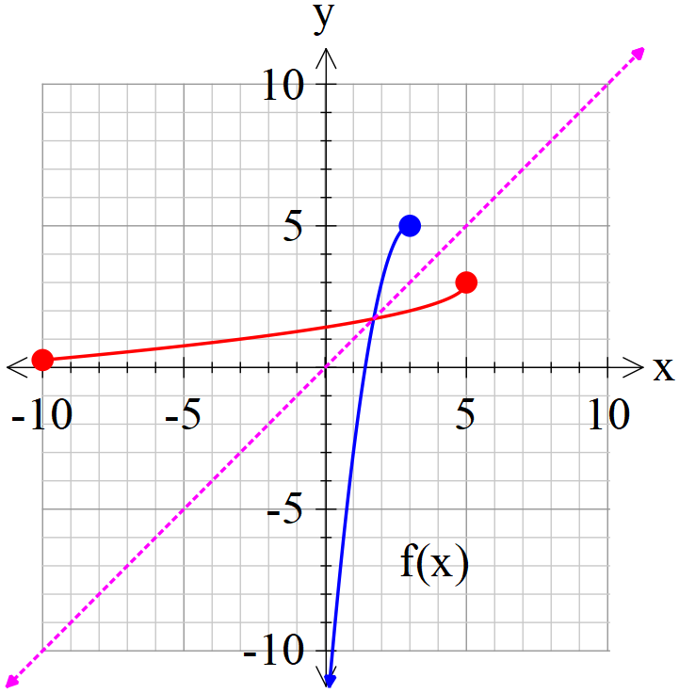

Specific behaviours
reflects in line y=x
inverse contains pt (5,3)

- Given that , determine the defining rule for .

Solution
Specific behaviours
interchanges x and y to solve for inverse
states possible rules for inverse
states correct rule with negative only

- Consider the function where is a positive constant. Solve in terms of , the solution(s) to .

- Solution
Specific behaviours
sets up equation in terms of x & a
factorises equation
states all three x values in terms of a.

Working out space

